Hardware programs

Interfacing 8086 with I/O devices through 8255

8086

8255

I/O device

8255 is available in
the I/O card fitted into
IBM pc expansion slot
of mother board

IBM PC has expansion slots, through these slots different I/O card can be connected. All the address lines, data lines and control signals from the microprocessor are available for the expansion of the system. For simple I/O device interface, an I/O card with 8255 chip is available. This card can be fit into the slot available in the mother board. Pin outs of 8255 are made available through a connector outside the system. Different I/O modules can be connected to the I/O card output connector using a flat cable.

8255

8255 is a Programmable Peripheral device used for parallel data transfer. It has 40 pins. Out of 40 pins, 24 pins are I/O pins which may be individually programmed in 3 groups of 8-bit ports: port-A, port-B and port-C.
Port-C can be grouped into two 4-bit ports C_{upper} and C_{lower}
PA₀

PA₇
8255 PB₀

PB₇
PC₀

PC₃
PC₄

PC₇

.
.
.

.
. Fig. 8255 Pin diagram

.
.

.
.

Features of 8255

- It can be programmed to transfer data from i/o device.
- It has 3 8bit ports : portA, portB and portC

What is a port?
A port is usually an interface through which data are sent and received

Operating modes of 8255

The 8255 can operate in three I/O modes: mode0, mode1 and mode2

In mode0, Port A & Port B, Port C_{U} & Port C_{L} can be configured as simple 8-bit input or output ports.

All these modes can be selected by programming a register internal 8255 known as control word register (CWR).
The ports of 8255 can be programmed by writing a single control word into the control register when required

Control word format

7 6 5 4 3 2 1 0

Mode set flag Port C(lower)
1= active 1-i/p, 0-o/p
Mode selection Port B
00-mode0 1-i/p, 0-o/p
01-mode1 mode selction
xx-mode2 0- mode0, 1- mode1

Port A Port C (upper)
1- i/p, 0-o/p 1-i/p, 0-o/p

Exercise1: Write a control word to initialize 8255 port C as output port

1 0 0 0 0 0 0 0 0

Control word = 80H

Program:
mov dx, 0123h ; address of control word register into dx
mov al, 80h ; load al with control word
out dx,al ; send control word
Stepper motor

A stepper motor is an electromechanical device which converts electrical pulses into discrete mechanical movements. The shaft or spindle rotates in discrete step increments when electrical pulses are applied in proper sequences.
Stepper can be good choice whenever controlled movement is required. They can be used advantage in application where you need to control rotation angle, speed, position, and synchronization. Examples: In printers, hard disk drive, fax machines etc.
The operating voltage is +12V D.C. The step angle is 1.8 degrees.

The parts:
Rotor: the rotating center position. Term may refer to the winding that is on the rotor.
Stator: the stepper motor has 4 stator winding around the rotor.
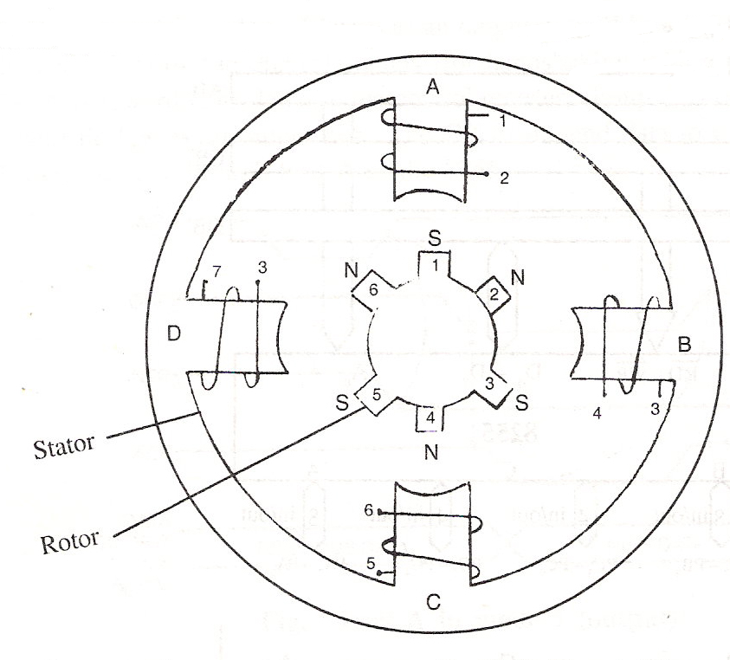

To control the direction and speed appropriate pulses are applied to the stator windings of the motor.
Four pins (PC0, PC1, PC2 and PC3) of an 8255 are used to excite the windings. Each of the four pins are connected to the respective windings through an interfacing circuit.
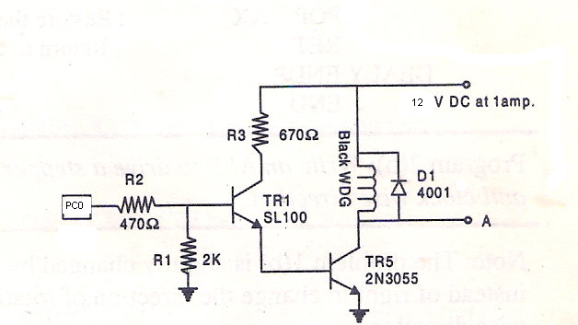

Fig. Stator winding
connection

General diagram of the stepper motor interfacing is given below.

8086

A
PC₀

PC₁
8255
PC₂

PC₃
Stepper
B Motor
Windings
C

D

8b) Drive a stepper motor interface to rotate the motor in clockwise (or anti clockwise)
direction by N steps. Introduce suitable delay between successive steps.

.model small
.stack 200
.data
pa=1080h
pb=1081h
pc=1083h
cw=1084h ; control word register address
n dw 200 ; counter to rotate stepper motor 200 steps i.e. 360 degrees
msg db 'rotation in clock wise','$'
.code
mov ax,@data
mov ds,ax ; initialization of data segment within code segment

lea dx,msg ; to display message
mov ah,09h
int 21h

mov dx,cw ;control word to make port-C as output
mov al,80h
out dx,al

mov cx,n
mov al,88h ; data to excite one of the winding of the stepper
mov dx,pc

again:
out dx,al
call delay ; call delay so that stepper motor rotates by an angle 1.8 degree

ror al,1 ; Rotate to excite the next winding
loop again ; Repeat to excite the winding
mov ah,4ch ; Terminate the program
int 21h

; ---delay procedure---

delay proc
push si
push cx
mov si,2000h
L2: mov cx,0ffffh
L1: loop L1
dec si
jnz L2
pop cx
pop si
ret
delay endp
end

LOGIC CONTROLLER
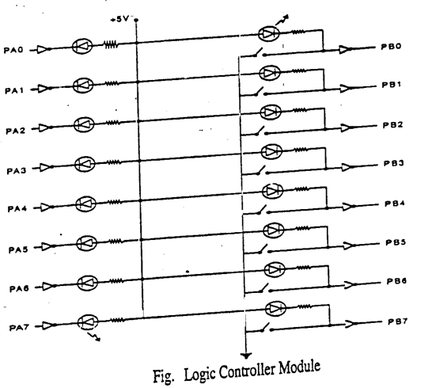

1. b) Read the status of eight input bits from the Logic Controller Interface and
display ‘FF’ if it is the parity of the input read is even; otherwise display 00.

.model small
.stack 200
.data
pa=1080h ; port address assigned in order
pb=1081h
pc=1082h
cw=1084h
msg db 'press any key to come to dos prompt','$'
.code
mov ax,@data
mov ds,ax

lea dx,msg ; interrupt to display the message
mov ah,09h
int 21h

mov dx,cw ; control word decision
mov al,82h ; pa=o/p
out dx,al ; pb=i/p

bg:
mov dx,pb ; accept the i/p
in al,dx

mov cx,8 ; counter register
mov bl,0 ; to keep track of no. of 1’s present in i/p

ag:
rol al,1
jnc noincbl
inc bl

noincbl:
loop ag

; to display the count to pc
mov al,bl
mov dx,pc ; o/p through port c
out dx,al

; to check for even/odd parity
mov dx,pa
ror bl,1
jc disp00

mov al,0ffh ; all LED,s in ON state, since parity is even
jmp nxt

disp00:
mov al,00 ; all LED,s in OFF state, since parity is odd

nxt:
out dx,al ; o/p through port a
---------------------------------
mov dl,0ffh ; to repeat the program with different values
mov ah,06h ; interrupt that waits until any key
int 21h ; or i/p is accepted
jz bg
---------------------------------
mov ah,4ch
int 21h
end

2.b) Implement a BCD Up-Down Counter on the Logic Controller Interface.

.model small
.stack 200
.data
pa=1080h ; port address assigned in order
pb=1081h
pc=1082h
cw=1083h
msg db 'press any key to come to dos prompt$'

.code
mov ax,@data ; initialization of data segment in CS
mov ds,ax

lea dx,msg
mov ah,09h ; interrupt to display the message
int 21h

mov al,82h ; control word decision
mov dx,cw ; pa=o/p
out dx,al

mov al,0
back:
push ax
mov dx,pa
out dx,al
call delay

mov dl,0ffh
mov ah,06h ; interrupt that waits until any key is pressed
int 21h
jnz exit

mov dx,pb ; accepting the i/p from port B
in al,dx
ror al,1
pop ax
jc up
down:
sub al,1
das
jmp back
up:
add al,1
daa
jmp back

exit:
mov ah,4ch
int 21h

;---delay procedure-----

delay proc
push si
push cx
mov si,2000h
l2: mov cx,0ffffh
l1: loop l1
dec si
jnz l2
pop cx
pop si
ret
delay endp

end

3. b) Read the status of two 8-bit inputs (X & Y) from the Logic controller Interface and display X*Y.

.model small
.stack 200
.data
pa=1080h ; port address assigned in order
pb=1081h
pc=1082h
cw=1083h
m1 db 10,13,’ enter 1st data from port B:$’
m2 db 10,13,’ enter 2nd data from port B:$’
msg db 'press any key to come to dos prompt$'
.code
mov ax,@data ; initialization of data segment in CS
mov ds,ax

mov dx,cw ; control word decision
mov al,82h
out dx,al

lea dx,m1
mov ah,09h ; interrupt to display the message
int 21h

mov dx,pb ; accepting the 1’st i/p from port B
in al,dx
mov bl,al

lea dx,m2
mov ah,09h ; interrupt to display the message
int 21h

call delay
call delay

mov dx,pb ; accepting the 2’nd i/p from port B
in al,dx

mul bl
push ax
mov al,ah
mov dx,pa
out dx,al

call delay
pop ax
mov dx,pa
out dx,al

mov ah,4ch
int 21h

delay proc ; procedure with suitable delay
push si
push cx
mov si,2000h
l2:mov cx,0ffffh
l1:loop l1
dec si
jnz l2
pop cx
pop si
ret
delay endp

end

Digital to Analog Module

DAC module consists of 0800 DAC chip, an Op-amp. The output voltage of +5V is obtained from the DAC when the digital input is FFH and output will be 0 Volts when the digital input is 00H.
The output of the DAC 0800 is fit to the Op-amp to get the final output at XOUT.

8255
PortA/PortB

+12V

DAC 0800
Xout

-12V

The parallel 8-bits data can be fed into the DAC from PortA and PortB. The required +12V, -12V and GND are supplied from an external power supply to the module. The X_{OUT} should be connected to the CRO to read the analog o/p data. Programming 8255 interfaced to DAC can generate the required waveform.

The waveform is shown below

FFH

80H

00H

The formula to calculate points: 128 + 128 sinθ
If θ = 0 , point1 = 128 + 128 sin0 = 128 + 0 =128(in decimal) = 80H ( in hex)
θ = 90, point = 128 + 128 sin90 = 128 + 128 = 256(in decimal)= FFH (in hex)
Similarly if θ = 180, point N = 128 + 128 sin 180 = 128 = 80H (in hex)

9b).Generate the Sine Wave using DAC interface (The output of the DAC is to be displayed on the CRO).

.model small
.stack 200
.data
pa=1080h ; port address assigned in order
pb=1081h
pc=1082h
cw=1083h
table db 128,151,172,192,211,226,239,248,254,255,254,248
db 239,226,211,192,172,151,128,106,84,64,46,30,17,08,02,
db 00,02,08,17,30,46,64,84,106
msg db 'press any key to come to dos prompt','$'
.code
mov ax,@data ; initialization of data segment
mov ds,ax

lea dx,msg
mov ah,09h ; interrupt to display the message
int 21h

mov dx,cw
mov al,80h ; control word decision
out dx,al
start:
mov cx,36
lea si,table
back:
mov al,[si]
mov dx,pa ; output the data through port
out dx,al

mov dx,pb
out dx,al
inc si
loop back

mov ah,01
int 16h
jz start
mov ah,4ch
int 21h
end

10.b) Generate a Half Rectified Sine Wave using DAC interface (The output of the DAC is
to be displayed on the CRO).

.model small
.stack 200
.data
pa=1080h ; port address assigned in order
pb=1081h
pc=1082h
cw=1083h

table db 128,151,172,192,211,226,239,248,254,255,254,248
db 239,226,211,192,172,151,128,128, 128, 128, 128, 128
db 128, 128, 128, 128, 128,128, 128, 128, 128, 128, 128

msg db 'press any key to come to dos prompt','$'

.code
mov ax,@data ; initialization of data segment
mov ds,ax

lea dx,msg
mov ah,09h ; interrupt to display the message
int 21h

mov dx,cw
mov al,80h ; control word decision
out dx,al
start:
mov cx,34
lea si,table
back:

mov al,[si]
mov dx,pa ; output the data through port
out dx,al

mov dx,pb
out dx,al
inc si
loop back

mov ah,01
int 16h
jz start
mov ah,4ch
int 21h
end

11.b) Generate a Fully Rectified Sine Wave using DAC interface (The output of the DAC is
to be displayed on the CRO).

.model small
.stack 200
.data
Pa=1080h ; port address assigned in order
pb=1081h
pc=1082h
cw=1083h

table db 128,151,172,192,211,226,239,248,254,255,254,248
db 239,226,211,192,172,151,128
msg db 'press any key to come to dos prompt','$'

.code
mov ax,@data ; initialization of data segment
mov ds,ax

lea dx,msg
mov ah,09h ; interrupt to display the message
int 21h

mov dx,cw
mov al,80h ; control word decision
out dx,al

start:
mov cx,18
lea si,table

back:
mov al,[si]
mov dx,pa ; output the data through port
out dx,al

mov dx,pb
out dx,al
inc si
loop back

mov ah,01
int 16h
jz start
mov ah,4ch
int 21h
end

Seven segment LED display interface

Seven segment display interface provides a four digit 7 segment display driven by the output of four cascaded serial-in parallel-out shift registers. Hex code of Character/digit to be displayed is transmitted serially bit by bit to the interface over the port line PB_{0.}
Characters are displayed starting from the last display (i.e. fourth one)
Each bit is clocked into the shift registers by providing a clock through the port line PC_{0.}

Figure shows the schematic of the seven segment display interface
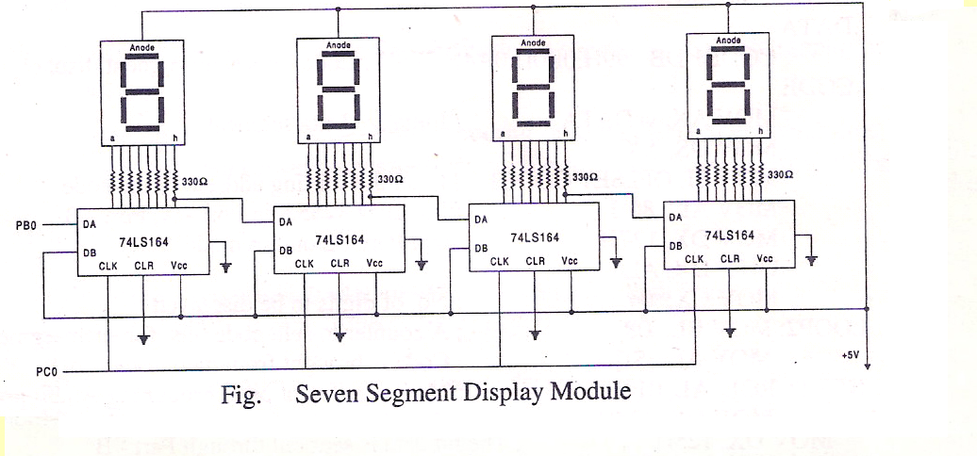

Each display has seven segments and a dot ( a,b,c,d,e,f,g,h and . )
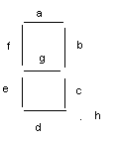
It is shown in the figure below.

    - glow
    - blank

For displaying any character the corresponding segments must be given low inputs.
Example:
For displaying digit 3, segments a, b, c, d, g must be given low inputs (i.e. 0’s) and the rest high inputs (i.e. 1’s)

Segment | h | g | f | e | d | c | b | a
Inputs | 1 | 0 | 1 | 1 | 0 | 0 | 0 | 0
Hex code | B |  |  |  | 0

Code to display digits are given in the table below

Displayed Digit | Hex code
0 | C0
1 | F9
2 | A4
3 | B0
4 | 99
5 | 92
6 | 82
7 | F8
8 | 80
9 | 90
Displayed Digit | Hex code
A | 88
b | 83
c | C6
d | A1
E | 86
F | 8E

4b) Display FIRE and HELP alternatively with flickering effects on a seven
segment display interface for a suitable period of time. Ensure a flashing rate
that makes it easy to read both the messages.

.model small
.stack 200
.data
pa=1080h
pb=1081h
pc=1082h
cr=1083h
msg db 'press any to come to dos prompt$'
fire db 86h,0ceh,0cfh,8eh ;codes to store chars E, r, I, F
blnk db 0ffh,0ffh,0ffh,0ffh ;codes to store 4 blanks
help db 8ch,0c7h,86h,89h ;codes to store chars P, L, E, H
.code
mov ax,@data
mov ds,ax

lea dx,msg
mov ah,09h
int 21h

mov dx,cr ;initialize 8255 with portB and portC as output ports
mov al,80h ;no need of input ports here
out dx,al

again:
lea si,fire ;initially, point si to address of code of E in ERIF,
call disp ;then display E, then R, I, F successively
call delay ;call delay between displays of FIRE and HELP

lea si,blnk ;point si to the blanks, to clear all 4 7-seg LED
call disp ;displays
call delay

lea si,help ;initially, point si to address of code of P in PLEH,
call disp ;then display P, then L, E, H successively
call delay

lea si,blnk
call disp
call delay

mov ah,01 ;DOS subfunction 01h of 16h checks whether key has
int 16h ;been pressed on keyboard, if so, stop and return to DOS
jz again ;else continue with flickering display

mov ah,4ch
int 21h

;-----display procedure----
disp proc
mov cx,4 ;load cx with number of chars to display
nxtchr:
mov bl,8 ;load bl with number of segments in each char
mov al,[si] ;al has the code of first char to display
nxtbit:
rol al,1 ;LSB of al has data for on/off of a-seg, and so on, and
;MSB of al has data for on/off of h-seg. But first data
;sent to 7-seg LED has to be for h-seg. So we rotate the
;MSB into LSB position and send this bit to h-seg to on/off it.
mov dx,pb
out dx,al ;the LSB in al is sent on portB to 7-seg LED

push ax ;since al is used to send clock signal, save current
;contents on stack

mov dx,pc
mov al,00 ;send data pulse thro portC, first low (00h), then high (0ffh).
out dx,al ;This pulse, along with on/off data, will on/off
mov al,0ffh ;the particular segment
out dx,al

pop ax ;restore contents of al from stack to continue with
;remaining segments of same 7-seg LED.

dec bl ;are all segments displayed?
jnz nxtbit ; if not, display remaining segments
inc si ;point to the code of next char to be displayed

loop nxtchr ;are all chars displayed? if not, display remaining characters
ret
disp endp

;-----delay procedure------
delay proc
push dx
push cx
mov dx,4000h
l2: mov cx,0ffffh
l1: loop l1
dec dx
jnz l2
pop cx
pop dx
ret
delay endp

end

5b) Assume any suitable messages of 12 characters length and display it in the
rolling fashion on a seven segment display interface for a suitable period of
time. Ensure a flashing rate that makes it easy to read both the messages.

.model small
.stack 200
.data
pa=1080h
pb=1081h
pc=1082h
cr=1083h
msg db 'press any to come to dos prompt$'
table db 80h,0c0h,80h,92h,80h,0c0h,80h,92h,80h,0c0h,80h,82h ;code to display
; characters ‘808580858086' in rolling fashion
.code
mov ax,@data
mov ds,ax

lea dx,msg
mov ah,09h
int 21h

mov dx,cr ;initialize 8255, portB and portC as outputs
mov al,80h ;input ports are not required
out dx,al
again:
mov cx,12 ;cx is counter for number of characters to be displayed
lea si,table ;point si to code of the first char to be displayed

nxtchr:
mov al,[si] ;get the code of the character to be displayed into al
call disp ;display the character on 7-seg LED, whose code is in al
call delay

mov ah,01 ;check for keypressed on kdb to quit program in
int 16h ;the middle of execution
jz again

inc si
loop nxtchr
jmp again

mov ah,4ch
int 21h

;-----display procedure----
disp proc
mov bl,8

nxtbit:
rol al,1
mov dx,pb
out dx,al
push ax

mov dx,pc
mov al,00
out dx,al

mov al,11h
out dx,al

pop ax
dec bl
jnz nxtbit
ret
disp endp

;-----delay procedure------
delay proc
push dx
push cx
mov dx,4000h
l2: mov cx,0ffffh
l1: loop l1
dec dx
jnz l2
pop cx
pop dx
ret
delay endp
end

6b) Convert a 16-bit binary value to BCD and display from left to right and right
to left for specified number of times on a seven segment display interface.

.model small
.stack 200
.data
pa equ 1080h
pb equ 1081h
pc equ 1082h
cr equ 1083h
m1 db 10,13,"press any key to continue$"
msg db 0ffh,0ffh,0ffh,0ffh,?,?,?,?,?,0ffh,0ffh,0ffh,0ffh ; 5 places are left blank in
; memory because the largest
; hexadecimal number that can
; be entered is ffffh which is
; 65535 in BCD
table db 0c0h,0f9h,0a4h,0b0h,99h,92h,82h,0f8h,80h,98h ; 7-seg codes corresponding
; to digits 0, 1 … 9.
num dw 0ffffh ; the hex number to be converted to BCD is input here, the
; result we expect is 04728
bcd db 5 dup(?) ; the BCD digits of the hex number above is stored here, prior to
; display

.code
mov ax,@data
mov ds,ax

lea dx,m1
mov ah,09
int 21h

mov al,80h
mov dx,cr
out dx,al

call bin_ssc ; procedure to convert the hex number in num to BCD, extract the BCD
; digit-by-digit, and store these digits inside the msg array for display

start:
mov bh,10
lea di,msg
back:
mov si,di
push bx
call disp_msg ; in msg table, 10 chars are displayed from left hand side
call delay
call kbhit ; continue displaying 10 characters from left and right hand side, until
; a key is pressed

pop bx
inc di
dec bh
jnz back
mov bh,10
lea di,msg+9
back1:
mov si,di
push bx
call disp_msg ; in msg table, 10 chars are displayed from right hand side
call delay
pop bx
dec di
dec bh
jnz back1
jmp start
bin_ssc proc
mov ax,num ; load the hex number into ax
lea si,bcd ; point si to bcd table
mov bx,10000 ; load bx with 10000 to extract the digit 0 in number 04728
call convert ; procedure to extract the k+1th digit in ax, where 10^k=bx
mov bx,1000
call convert
mov bx,100
call convert
mov bx,10
call convert
mov [si],dl ; after extracting the last-but-one digit, the last digit will already be in
; dl, so it can directly be moved to the proper place in bcd table
lea si,bcd ; si points to bcd table
lea di,msg+8 ; di points to msg table, where we store the 7-seg codes of digits that
; are stored in bcd table
lea bx,table ; bx points to the 7-seg code lookup table
mov cx,5 ; cx is a counter, there are 5 digits to encode to 7-seg
next: mov al,[si] ; load into al the BCD digit to be encoded
xlat ; al has the 7-seg code corresponding to the BCD digit earlier in al
mov [di],al ; store this encoded value into msg table
dec di
inc si
loop next ; repeat encoding for the remaining BCD digits
ret
bin_ssc endp

convert proc
mov dx,0 ; dx_ax represents the dividend, but ax has the number, so dx=0
div bx
mov [si],al ; quotient is stored in ah_al, but we consider only al because the quotient
; is small (8bit). Store this digit in the location pointed by si, in bcd table
mov ax,dx ; dx has the remainder, and this is the number that we use to extract the
; next digit
inc si ; point to the space where the next BCD digit will be stored
ret
convert endp

kbhit proc
mov ah,1
int 16h
jnz exit
ret
exit: mov ah,4ch
int 21h
kbhit endp

disp_msg proc
mov cx,04
nxtchar:
mov bl,08
mov al,[si]

nxtbit: rol al,1
mov dx,pb
out dx,al
push ax
mov dx,pc
mov al,0
out dx,al
mov al,11h
out dx,al
pop ax
dec bl
jnz nxtbit
inc si
loop nxtchar
ret
disp_msg endp
delay proc
push bx
push cx
mov bx,04fffh
b2:mov cx,0ffffh
b1:loop b1
dec bx
jnz b2
pop cx
pop bx
ret
delay endp
end

Key Board Interface

The keyboard interface, which can be operated like a hand held calculator. The key board has 8 rows and three columns. At the intersection of rows and columns a key board is provided. portA is connected to the rows ( scan lines) and portC is connected to columns of the keyboard. By programming 8255, it is possible to sense the keyboard interface is illustrated in the figure below.

Port A: Input Port
0 8 C PA₀

1 9 CE
PA₁

2 . PA₂

3 +
PA₃

4 - PA₄

5 ×
PA₅

6 /
PA₆

7 ٪
PA₇
PC₀ PC₁ PC₂
Port C: output port Figure. Keyboard interface module

7
87
97
+7
–

47
57
67666
×
7
Fig: KeyPad Layout
17
27
37

CE7
.7
07
C
٪

Port A is programmed as input port to read rows and port C as output port to select a column. For example, if 001 is output to port C i.e. pin PC2-PC0, the column zero has logic 1, so the 8 keys in column zero are selected.

Keyboard:
Keyboard consists of 20 keys. It consists of numerals 0-9, the special charcters +,-, ×, ٪, . , C, CE and two blank keys. The keys have been organized as four rows of five keys. Each in a sense matrix of 8 rows and 3 columns.

The program will scan the keyboard row by row and checks whether any key is closed.. if it finds a key closure, it will find the code of the closed key and displays it.
Key code corresponding to each key will be displayed & is given below.

Key | Code | Key | Code
0 | 0 | . | A
1 | 1 | + | B
2 | 2 | - | C
3 | 3 | × | D
4 | 4 | / | E
5 | 5 | ٪ | F
6 | 6 | C | 10 (G)
7 | 7 | CE | 11 (H)
8 | 8 | Blank | 12 (I)
9 | 9 | Blank | 13 (J)

7b) Scan a 8×3 key pad for a key closure and store the code of key pressed in the memory
locations or display on the screen. Also display row and column numbers of the key pressed.

.model small
.data
mes1 db "the row number is: "
row db ?,10,13,"$"
mes2 db "the col number is: "
col db ?,10,13,"$"
table db "0123456789abcdefghij$"
pa=1080h
pb=1081h
pc=1082h
cr=1083h
msg db "press any key to come to dos$"
m1 db 10,13,"entered key is:$"
.code
mov ax,@data
mov ds,ax

mov al,90h ; Initialize 8255, port-A input, port-C output
mov dx,cr
out dx,al

lea dx,msg
mov ah,09h
int 21h

rpt:
mov dl,0ffh
mov ah,06h
int 21h
jz down
jmp quit
down: mov dx,pc ;o/p high through port-C (PC₀)
mov al,01 ; i.e., first column of the keyboard
out dx,al

mov dx,pa
in al,dx ;read status of kbd through port-A
cmp al,00h ; check if any key from the first column is pressed
jz next ; Is it still zero? Yes, go to read next column
jmp f_c ; No, check for key pressed in first col?

next:mov dx,pc ;o/p high through port-C (PC₁)
mov al,02 ; i.e., second column of the keyboard
out dx,al

mov dx,pa
in al,dx ;read status of kbd through port-A
cmp al,00h ; check if any key from the second column is pressed
jz next1 ; Is it zero? Yes, go to read next column
jmp s_c ; No, check for key pressed in second col?

next1: mov dx,pc
mov al,04 ;o/p high through port-C (PC₂)
out dx,al ; i.e., third column of the keyboard

mov dx,pa
in al,dx ; read status of kbd through port-A
cmp al,00 ; check if any key from the third column is pressed
jnz t_c ; Is it zero? No, check for key pressed in second col?
jmp rpt ; yes repeat from the beginning.

f_c: mov col,30h
mov cl,30h
call delay ; delay is called for bouncing effect
lea si,table ; initialize si with key code of first key
n1: shr al,01h
jc disp ; check whether it is in that row a key is pressed ? yes go to display
inc si ; no check for remaining rows in which key is pressed
inc cl
jmp n1

s_c: mov col,31h
mov cl,30h
call delay
lea si,table ;initialize si with code address of second column first key
add si,8
n2:shr al,01h
jc disp
inc si
inc cl
jmp n2
t_c:
mov col,32h
mov cl,30h
call delay
lea si,table ;initialize si with code address of second column first key
add si,10h
n3:shr al,01h
jc disp
inc si
inc cl
jmp n3
disp:
lea dx,m1
mov ah,09h
int 21h
mov dl,[si]
mov ah,02h
int 21h
mov row,cl
lea dx,mes1
mov ah,09h
int 21h
lea dx,mes2
int 21h
jmp rpt
quit:mov ah,4ch
int 21h
delay proc
push cx
mov bx,2000h
L1:mov cx,0ffffh
L2:loop L2
dec bx
jnz L1
pop cx
ret
delay endp
end

Elevator
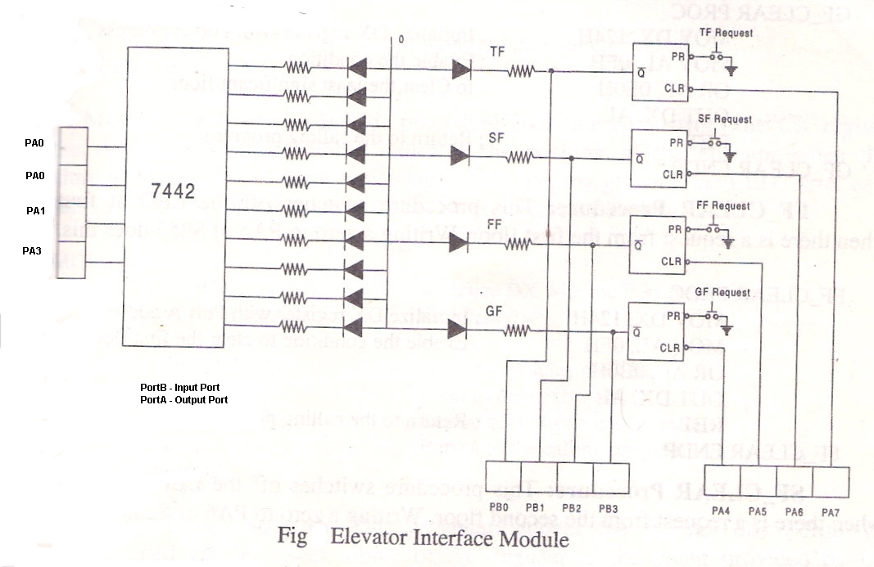

The control and operation of elevator can be simulated by the use of elevator interface. The elevator has four floors. A key and corresponding LED indicator serves as a request button and request status indicator. There are 10 LED’s to indicate the position of the elevator. The turning on/off of the successive LED’s one at a time in fixed intervals of time indicate the position of the elevator. The LED’s are controlled by the port A(PA0-PA3) of 8255 which is used as output port.
The request of any of the floors is indicated by means of a request button.
The request can be recognized by the position through port-B (Pb0-Pb3) of 8255, which acts as the input port.

12b) Drive an elevator interface in the following way to move the elevator from
ground to top floor and top to ground floor

.model small
.data
pa=1080H
pb=1081H
pc=1082H
cr=1083H
.code
mov ax,@data
mov ds,ax

mov dx,cr ; initialize 8255, portA as output port, portB as input port
mov al,82h
out dx,al

mov al,00h ;initialize all LED,s to OFF state
mov dx,pa
out dx,al

mov al,0f0H ; position to ground floor
out dx,al ; first LED is ON
mov dx,pb
scan:
in al,dx ; read the condition of floor switch
and al,0fh ; keep the lower nibble from portB and make 0s the higher nibble
cmp al,0fh ; is there a request from any floor ?
je scan ; no, go to check again

mov bh,00 ;initialize floor count to 0
ag: ror al,1 ; yes, is it ground floor ?
jnc skip ; yes, go to service it
inc bh
jmp ag ; No, request is from some other floor
skip:
mov ah,bh
shl ah,1
add ah,bh
add ah,0f0h ; calculate number of LEDs to glow for requested floor
mov al,0f0h
mov dx, pa
up: out dx,al
push ax
call delay
pop ax
inc al
cmp ah,al ; have all LEDs lit one after other?
jnc up ; if dest(ah) is > src(al) then no carry
dec al
call delay
call delay
call delay
and al,0fh ;to remove higher 4 bits
out dx,al ;send al to PA to turn off LED
or al,0f0h

down: out dx,al
push ax
call delay
pop ax
dec al
cmp al,0efh ;to check for ground floor
jne down
mov ah,4ch
int 21H

delay proc ; procedure with suitable delay
push dx
push cx
mov dx,3000h
l2:mov cx,0ffffh
l1:loop l1
dec dx
jnz l2
pop cx
pop dx
ret
delay endp

end

